#### Installation Steps-Nifi

1.Go to <https://nifi.apache.org/>

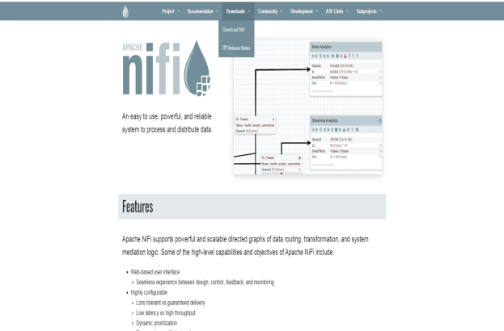

2. Go to downloads as shown above and choose the latest version.

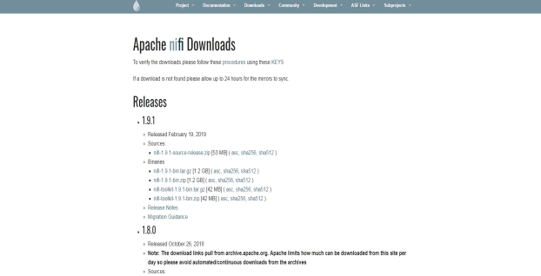

3. Click on the hyperlink to download Nifi.

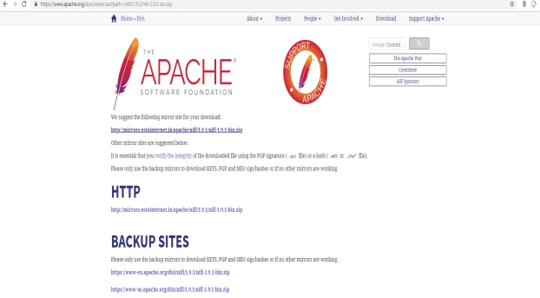

4.Once download completes, extract the files and go to bin folde.

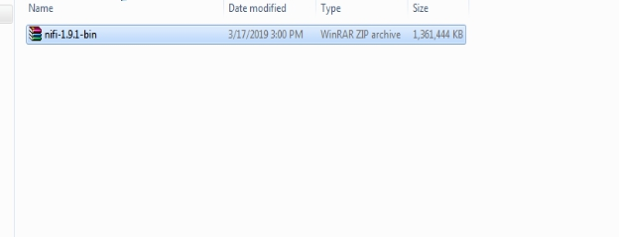

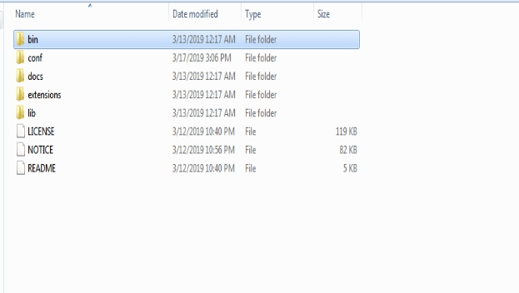

5. Now click run-nifi to it run

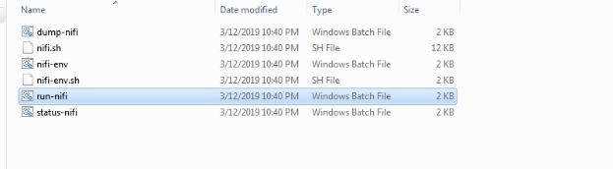

6. In your browser to to url <http://localhost:8080/nifi/>, you should see Nifi running.

